**Survey Test Case**

Test case records the result of a test. There are different formats of test cases used by different companies but there must be some mandatory fields that must be included in the test case. Spend around 15 – 20 minutes to search and observe different formats of test cases and identify the mandatory fields. List and explain these fields.

**Test Case for White Box Testing**

This practical aims at providing practice for the students to create test cases by following a template provided.

Study the following codes:

import java.util.Scanner;

class DecimalToOctalExample

{

public static void main(String args[])

{

Scanner input = new Scanner( System.in );

System.out.print("Enter a decimal number : ");

int num =input.nextInt();

/* Method 1:

* Using predefined method toOctalString(int)

* Pass the decimal number to this method and

* it would return the equivalent octal number

*/

String octalString = Integer.toOctalString(num);

System.out.println("Method 1: Decimal to octal: " + octalString);

/* Method 2:

* Writing your own logic: Here we will write

* our own logic for decimal to octal conversion

*/

// For storing remainder

int rem;

// For storing result

String str="";

// Digits in Octal number system

char dig[]={'0','1','2','3','4','5','6','7'};

while(num>0)

{

rem=num%8;

str=dig[rem]+str;

num=num/8;

}

System.out.println("Method 2: Decimal to octal: "+str);

}

}

(https://beginnersbook.com/2014/07/java-program-for-decimal-to-octal-conversion/)

1. Identify the test cases from the codes. For example; **TC1: To test the result of decimal to octal conversion**.
2. Based on the test cases identified, create THREE test cases (positive and negative test case). Your test case format **MUST** follow the provided test case template below.

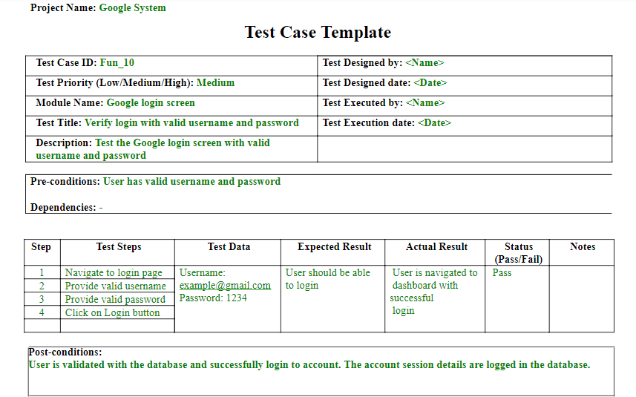

Figure 1: Test Case Template